SALES ANALYTICS SQL QUERIES
A.KPI ANALYSIS
1.Total_Revenue:
SELECT SUM(total_price) AS Total_Revenue FROM pizza_sales ;
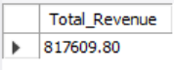
2.Total_Orders:
SELECT COUNT(DISTINCT order_id) AS Total_Orders FROM pizza_sales ;
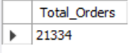
3.Average_Order_Value:
SELECT CAST(
CAST(SUM(total_price) AS DECIMAL(10,2))/
CAST(COUNT(DISTINCT order_id) AS DECIMAL(10,2)) AS DECIMAL(10,2)) AS Average_Order_Value FROM pizza_sales;
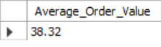
4.Total_Pizza_Sold:
SELECT SUM(quantity) AS Total_Pizza_Sold FROM pizza_sales ;
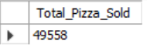
5. Average_Pizzas_Per_Order:
SELECT CAST(
CAST(SUM(quantity)AS DECIMAL(10,2))/
CAST(COUNT(DISTINCT order_id)AS DECIMAL(10,2)) AS DECIMAL(10,2)) AS Average_Pizzas_Per_Order FROM pizza_sales ;
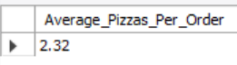
B.ANALYSIS(Based on Chart Requirements)
1.Monthly_Trend_For_Total_Revenue:
SELECT MONTHNAME(order_date) AS Month,
SUM(total_price) AS Total_Revenue FROM pizza_sales
GROUP BY MONTHNAME(order_date) ;
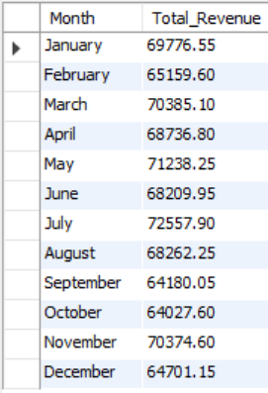
2.Daily_Trend_For_Total_Orders:
SELECT DAYNAME(order_date) AS Day,
COUNT(DISTINCT order_id) AS Total_Orders FROM pizza_sales
GROUP BY DAYNAME(order_date),WEEKDAY(order_date)
ORDER BY WEEKDAY(order_date);
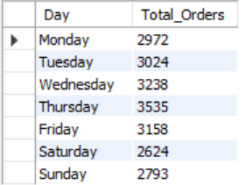
3.Percentage_Of_Sales_By_Pizza_Category:
SELECT pizza_category AS Pizza_Category,
SUM(total_price) AS Total_Revenue,
(CAST
(SUM(total_price) *100/
(SELECT SUM(total_price) AS Total_Revenue FROM pizza_sales)
AS DECIMAL(10,2))) AS pct_By_Category
FROM pizza_sales
GROUP BY pizza_category;
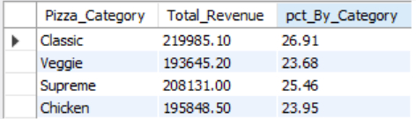
4.Percentage_Of_Sales_By_Pizza_Sales:
SELECT pizza_size AS Pizza_Size,
SUM(total_price) AS Total_Revenue,
(CAST
(SUM(total_price) *100/
(SELECT SUM(total_price) AS Total_Revenue FROM pizza_sales)
AS DECIMAL(10,2))) AS pct_By_Size
FROM pizza_sales
GROUP BY pizza_size;
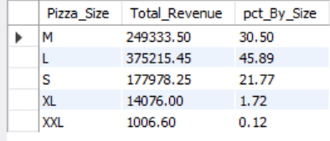
5.Total_Pizzas_Sold_By_Pizza_Size_And_Category:
SELECT pizza_size AS Pizza_Size,
SUM(total_price) AS Total_Pizzas_Sold FROM pizza_sales
GROUP BY pizza_size;
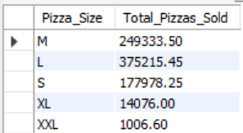
SELECT pizza_category AS Pizza_Category,
SUM(total_price) AS Total_Pizzas_Sold FROM pizza_sales
GROUP BY pizza_category;
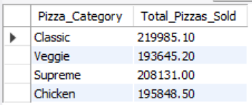
6.Revenue_By_Pizza_Name:
SELECT pizza_name AS Pizza_Name,
SUM(total_price) AS Total_Revenue FROM pizza_sales
GROUP BY pizza_name;
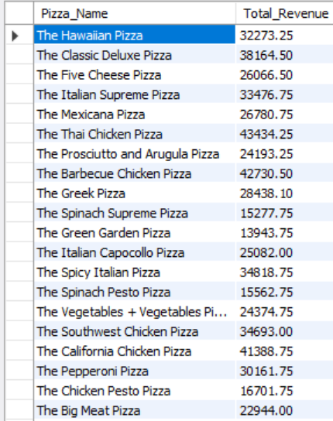
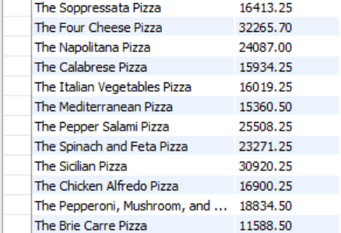
C.TOP & BOTTOM ANALYSIS
1. Top_5_Pizzas_By_Revenue:
SELECT pizza_name AS Pizza_Name,
SUM(total_price) AS Total_Revenue FROM pizza_sales
GROUP BY pizza_name
ORDER BY Total_Revenue DESC LIMIT 5;
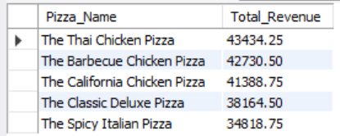
2. Worst_5_Pizzas_By_Revenue:
SELECT pizza_name AS Pizza_Name,
SUM(total_price) AS Total_Revenue FROM pizza_sales
GROUP BY pizza_name
ORDER BY Total_Revenue ASC LIMIT 5;
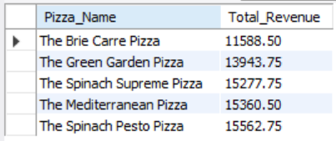
3.Top_5_Pizzas_By_Orders:
SELECT pizza_name AS Pizza_Name,
COUNT(DISTINCT order_id) AS Total_Orders FROM pizza_sales
GROUP BY pizza_name
ORDER BY Total_Orders DESC LIMIT 5;
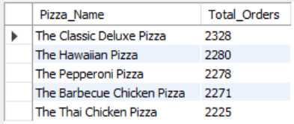
4. Worst_5_Pizzas_By_ Orders:
SELECT pizza_name AS Pizza_Name,
COUNT(DISTINCT order_id) AS Total_Orders FROM pizza_sales
GROUP BY pizza_name
ORDER BY Total_Orders ASC LIMIT 5;
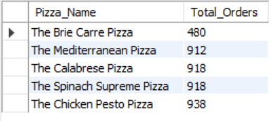
5. Top_5_Pizzas_By_Quantity_Sold:
SELECT pizza_name AS Pizza_Name,
SUM(quantity) AS Total_Quantity_Sold FROM pizza_sales
GROUP BY pizza_name
ORDER BY Total_Quantity_Sold DESC LIMIT 5;
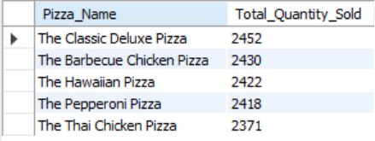
6. Worst_5_Pizzas_By_Quantity_Sold:
SELECT pizza_name AS Pizza_Name,
SUM(quantity) AS Total_Quantity_Sold FROM pizza_sales
GROUP BY pizza_name
ORDER BY Total_Quantity_Sold ASC LIMIT 5;
